Session 8

Depth Perception and Applications in Robotics

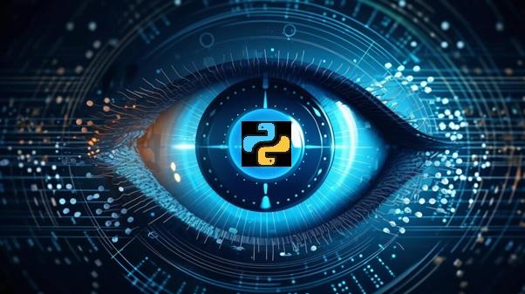

This session explains depth perception and applications in Robotics

Objectives

* Explain the basics of stereo vision for depth perception
* Describe LiDAR technology and its role in depth sensing
* Describe the concept of depth perception and its applications in robotics
* Explain the fundamentals of point clouds
* Illustrate processing, analysis, filtering, segmentation techniques, and feature extraction from point clouds
* Explain the integration of depth perception in robotics
* Illustrate challenges and future developments in applying depth perception to autonomous vehicles

8.1 Principles of Stereo Vision and LiDAR

Stereo Vision and LiDAR are two techniques that are used by modern robotics to visually sense the world.

8.1.1 Basics of Stereo Vision

Stereo vision, also known as stereopsis, is a technique used in computer vision and robotics that mimics human binocular vision. It involves capturing and processing images from two or more cameras to perceive depth and create a three-dimensional (3D) representation of the environment.

The working principle of stereo vision includes:

Applications of stereo vision are as follows:

8.1.2 LiDAR Technology

LiDAR, which stands for Light Detection and Ranging, is a remote sensing technology that uses laser light to measure distances. In robotics, LiDAR is employed for precise depth sensing and environmental mapping.

**Working Principle of LiDAR**: The working principle of LiDAR includes:

Applications of LiDAR are as follows:

8.2 Depth Perception Techniques

Depth perception is a cornerstone in robotics, unlocking the spatial dimension for machines to interpret and navigate their environment. There are various techniques employed for depth perception, shedding light on their principles and applications in the realm of robotics.

8.2.1 Understanding Depth Perception

Depth perception, the ability to perceive the world in three dimensions, is a cognitive marvel that robots strive to emulate. By comprehending the spatial relationships and distances between objects, robots equipped with depth perception capabilities can navigate, interact, and function more effectively.

Techniques for depth perception includes:

8.2.2 Applications in Robotics

**Applications of Depth Perception in Real-world Robotics**: Applications in robotics include:

The comprehension of depth perception is fundamental for robots to operate effectively and safely in real-world scenarios, making it a crucial aspect of robotic systems design and implementation.

**Robotics Navigation and Obstacle Avoidance**: The importance of robotics include:

8.3 Point Cloud Processing Basics

Point clouds serve as a rich source of spatial information, capturing the intricate details of a physical environment. The fundamental aspects of point cloud processing are explored from their introduction to the techniques used for analysis and feature extraction.

8.3.1 Introduction to Point Clouds

Point clouds are 3D representations of surfaces, constructed by collecting a multitude of points in space. These points, often obtained through technologies such as LiDAR or stereo vision, collectively create a detailed map of an object or environment.

**Characteristics**: Characteristics of point clouds include:

In point cloud, the developer can use open3d library of python to render the point cloud and see how point cloud looks.

To install all the necessary packages use this command in command line:

|  |
| --- |
| pip install open3d |

To download the point cloud file down any sample from this [site](https://people.sc.fsu.edu/~jburkardt/data/ply/ply.html).

Code Snippet 1 demonstrates the rendering of the point cloud using Open 3d library.

**Code Snippet 1**:

|  |
| --- |
| import numpy as np  import open3d as o3d  print("Load a ply point cloud, print it, and render it")  ply_point_cloud = './airplane.ply'  pcd = o3d.io.read_point_cloud(ply_point_cloud)  print(pcd)  print(np.asarray(pcd.points))  o3d.visualization.draw_geometries([pcd]) |

In Code Snippet 1, the developer utilizes the Open3D library to load a 3D point cloud from a PLY file named 'airplane.ply'. It prints information about the point cloud object, including its geometry details, and displays the coordinates of the points as a NumPy array. Finally, it visualizes the point cloud using the draw_geometries function from Open3D, providing an interactive 3D rendering of the loaded point cloud. Figure 8.1 shows the output of Code Snippet 1 rendered ply file. Figure 8.2 shows the output of Code Snippet 1.

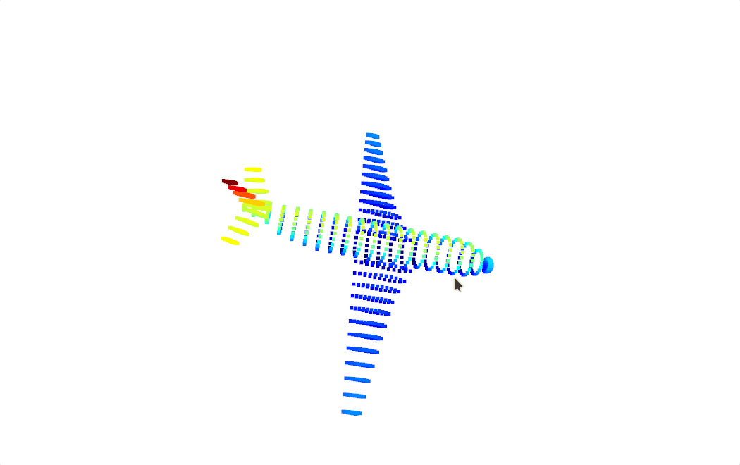Figure 8.1: Output of Code Snippet 1 Rendered Ply File

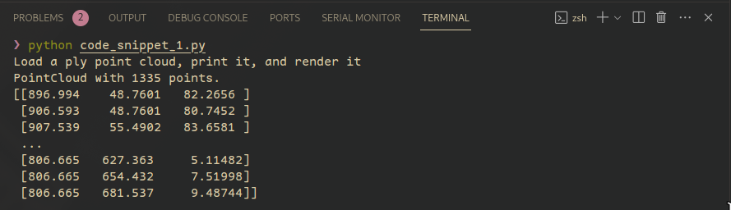

Figure 8.2: Output of Code Snippet 1

The output consists of three parts: Firstly, it confirms the successful loading of a point cloud with 1335 points. Secondly, it prints a snippet of the point coordinates as a NumPy array, illustrating the spatial distribution. Lastly, a separate window opens, visually presenting an interactive 3D rendering of the loaded point cloud, enabling exploration of its geometry as shown in Figure 8.1.

8.3.2 Processing and Analysis

To use Point cloud effectively, it has to be processed and analyzed.

Processing Steps of point cloud include:

Analysis techniques of point cloud include:

8.3.3 Filtering and Segmentation Techniques

**Filtering**:

**Noise Removal**: Eliminate outliers and sensor-generated noise for cleaner data.

**Smoothing**: Apply filters to reduce irregularities and create a smoother representation.

**Segmentation**:

**Region Growing**: Identify connected regions with similar properties.

**Plane Segmentation**: Separate point clouds into distinct planes, aiding in surface analysis.

8.3.4 Feature Extraction from Point Clouds

Features from point clouds include:

Applications of point cloud include:

Point cloud processing, from acquisition to feature extraction, is a critical step in leveraging 3D spatial data for applications in robotics, computer vision, and various other fields.

8.4 Applications in Robotics and Autonomous Vehicles

Robotics and autonomous vehicles leverage depth perception technologies to enhance their capabilities and navigate dynamic environments. The integration of depth perception in robotics is explored along with challenges and future developments in this rapidly evolving field.

8.4.1 Integration of Depth Perception in Robotics

**Enhanced Navigation**:

**Obstacle Avoidance**: Robots use depth perception to detect and navigate around obstacles, ensuring safe movement in cluttered environments.

**Terrain Understanding**: Depth perception aids in recognizing changes in terrain, helping robots adapt their locomotion for various surfaces.

**Object Manipulation**:

**Precise Grasping**: Robots equipped with depth perception can grasp and manipulate objects with accuracy, as they can estimate the distance and shape of the objects.

**Human-Robot Interaction**:

**Gesture Recognition**: Depth perception enables robots to interpret human gestures, facilitating more intuitive communication.

**Safe Collaboration**: Robots can work alongside humans more safely by perceiving their proximity and movements.

**3D Environment Mapping**:

**Spatial Awareness**: Depth perception contributes to creating detailed 3D maps of the environment, allowing robots to comprehend and navigate complex spaces.

**Vision-Based Control**:

**Autonomous Systems**: Depth perception is integral to the autonomy of robots, enabling them to make real-time decisions based on their comprehending of the surroundings.

8.4.2 Challenges and Future Developments

**Overcoming Challenges in Depth Perception Applications**: the challenges in depth perception include:

**Future Innovations in Robotics and Autonomous Systems**: Future developments include:

The integration of depth perception in robotics presents exciting opportunities for innovation. Overcoming current challenges and embracing future developments play a pivotal role in realizing the full potential of depth sensing technologies in autonomous systems.

**8.5 Summary**

* Stereo vision utilizes two cameras to calculate depth, while LiDAR measures distances using laser beams.
* Depth perception involves perceiving the world in three dimensions, employing techniques such as stereo vision, monocular cues, motion parallax, and focus cues.
* Point clouds are 3D representations created by collecting numerous points in space, with processing steps including data acquisition, registration, downsampling, and normalization.
* Analysis techniques for point clouds encompass surface reconstruction, object recognition, and change detection.
* Integration of depth perception in robotics enhances navigation, object manipulation, and human-robot interaction.
* Applications include obstacle avoidance, terrain understanding, precise grasping, 3D environment mapping, and vision-based control.
* Challenges in depth perception include real-time processing, adaptation to dynamic environments, and sensor limitations.
* Future developments involve advanced sensor technologies, ML integration, and standardized depth data formats.
* Depth perception is fundamental for robots, providing the ability to comprehend and interact with a 3D environment, with ongoing advancements shaping the field.

**8.6 Check Your Progress**

1. What is the primary role of LiDAR technology in robotics?

|  |  |  |  |
| --- | --- | --- | --- |
| **A** | Object recognition | **B** | Depth sensing |
| **C** | Surface reconstruction | **D** | Human robot interaction |

1. Which of the following techniques utilize the slight disparities between images captured by two or more cameras to calculate depth?

|  |  |  |  |
| --- | --- | --- | --- |
| **A** | Monocular cues | **B** | Motion parallax |
| **C** | Stereo vision | **D** | Focus cues |

1. What is the common application of point clouds in robotics?

|  |  |  |  |
| --- | --- | --- | --- |
| **A** | Image recognition | **B** | Audio processing |
| **C** | 3D environment mapping | **D** | Temperature sensing |

1. In point cloud processing, what is a key step in downsizing the data without losing essential details?

|  |  |  |  |
| --- | --- | --- | --- |
| **A** | Normalization | **B** | Registration |
| **C** | Downsampling | **D** | Analysis |

1. What is one of the challenges associated with depth perception in robotics?

|  |  |  |  |
| --- | --- | --- | --- |
| **A** | Reducing sensor accuracy | **B** | Real-time processing |
| **C** | Minimizing sensor range | **D** | Ignoring environmental changes |

**Answers to Check Your Progress**

|  |  |
| --- | --- |
| Question | Answer |
| 1 | B |
| 2 | C |
| 3 | C |
| 4 | C |
| 5 | B |

**Try It Yourself**

1. Apply basic point cloud processing techniques using the Open3d library in Python.